HOW TO REGISTER FOR RSC
------------------------------------------------
Retailer Showcase Registration

TABLE OF CONTENTS

Getting Started: Navigation to RSC 3

Seasonal Sales Registration 4

Retailer Registration 5

Select Retailer 5

Set Distribution Preferences 6

Select Mall(s) Responsible For 7

Select One Mall Responsible For 7

Select Multiple Malls Responsible For 7

Validate & Submit 8

NOTE

IF YOU DO NOT ALREADY HAVE A BASE TENANT/ TENANT UNDER THE MALL DIRECTORY, PLEASE SUBMIT A REQUEST HERE: WWW.SIMON.COM/BASETANT

IF YOU HAVE AN EXISTING TENANT UNDER THE MALL DIRECTORY, PLEASE FOLLOW THE STEPS BELOW:

GETTING STARTED

Navigation to Retailer Showcase
Navigate to the Retailer Showcase by going to www.simon.com/retailershowcase.

- Find the “register now” button and click on it to be directed to the application for RSC registration.

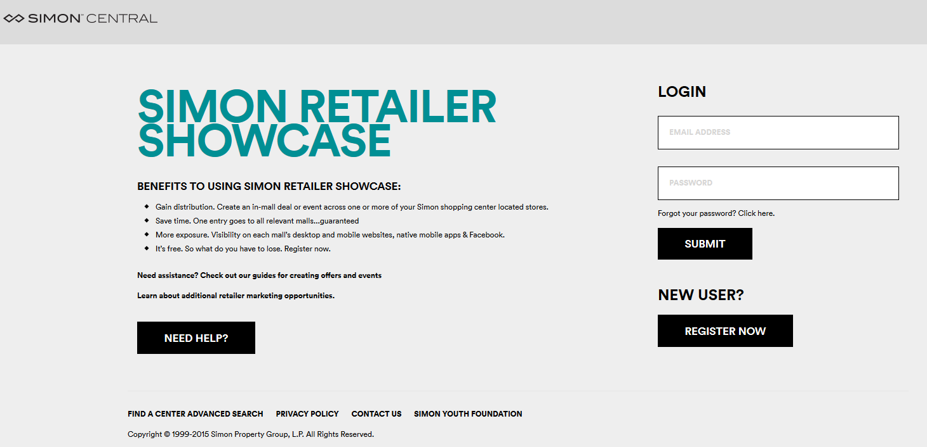

SEASONAL SALES REGISTRATION

- Find the “register now” button and click on it to be directed to the application for RSC registration.

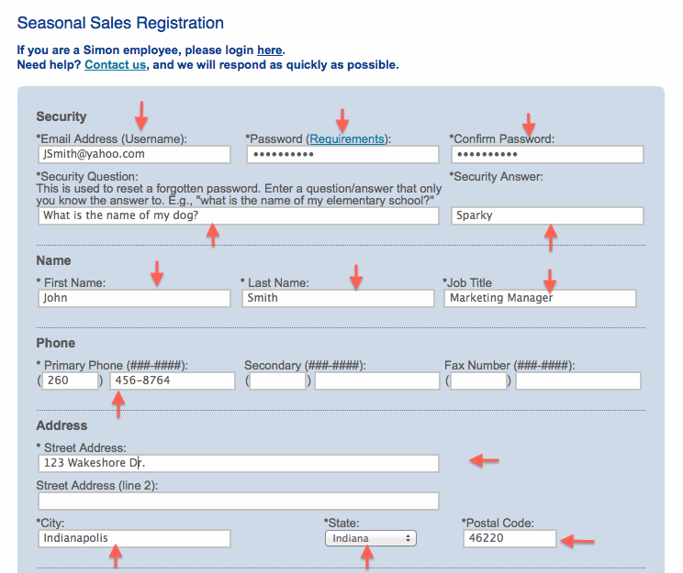

RETAILER REGISTRATION

Select Retailer
To navigate to the Retailer registration, scroll down to the “Retailer” section.

- Type in your retailers name then select from the drop down menu

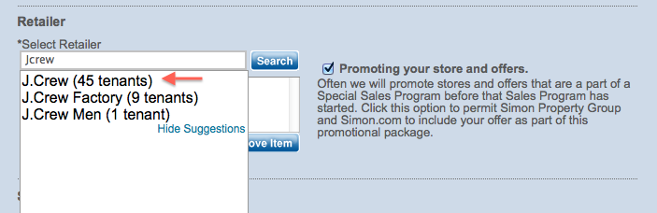

- Note: you can choose multiple retailers, one at a time by repeating step 5

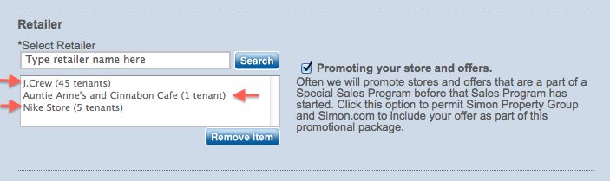

SET DISTRIBUTION PREFERENCES

- Find the “register now” button and click on it to be directed to the application for RSC registration.

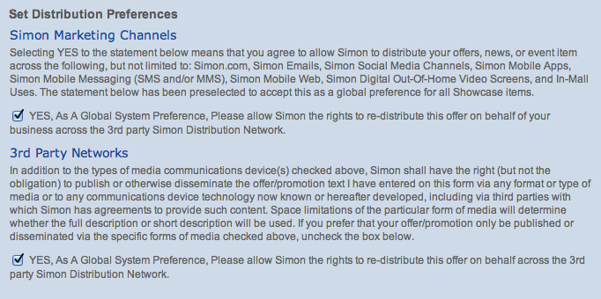

SELECT MALL(S) RESPONSIBLE FOR

SELECT ONE MALL

- Scroll down to “Malls Responsible For” to select the individual Simon Malls for the retail locations that you are responsible for
- Select the desired mall then click the arrow to send that mall from the “List of Malls” box to the “Selected Malls” box

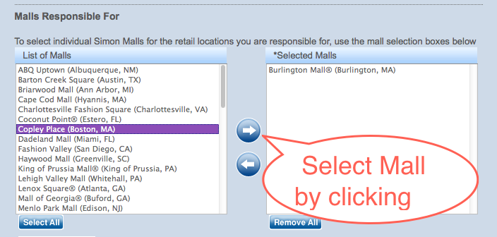

SELECT MULTIPLE MALLS

- Continue this selecting of a mall and clicking of the arrow process to add more than one mall

VALIDATE & SUBMIT

- Find the “register now” button and click on it to be directed to the application for RSC registration.

- Continue this selecting of a mall and clicking of the arrow process to add more than one mall

