MANAGING SIMON.COM WEBSITE NEWS ALERTS
Contents
What is an Alert? 1
What does an Alert look like? 1
Managing Alerts 4
Adding a new an Alert 4
Editing An Existing News Alert 6
Expire/Delete/Copy/Preview A News Alert 7

What is an Alert?
An alert will show at the top of your center’s website in a plum-colored banner. In this space you have 120 characters to display important messages, such as closures due to inclement weather. The alert will automatically show a link to your Facebook page so customers can check for updates. The banner may be dismissed by clicking the X on the right; if dismissed it will not show again unless the user clears cookies on his or her browser

What does an Alert look like?
Desktop:
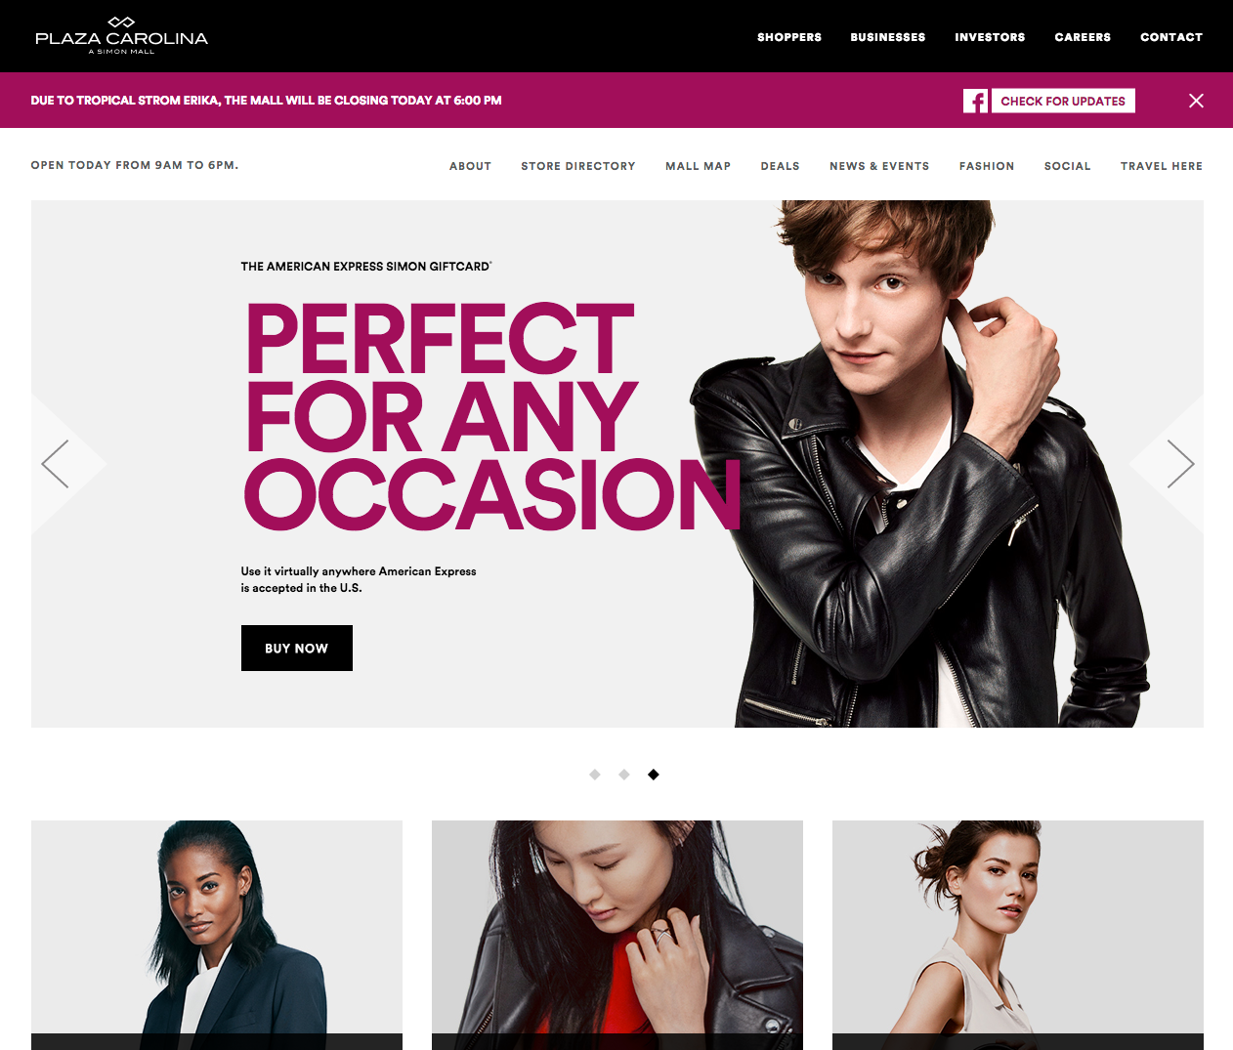
Mobile
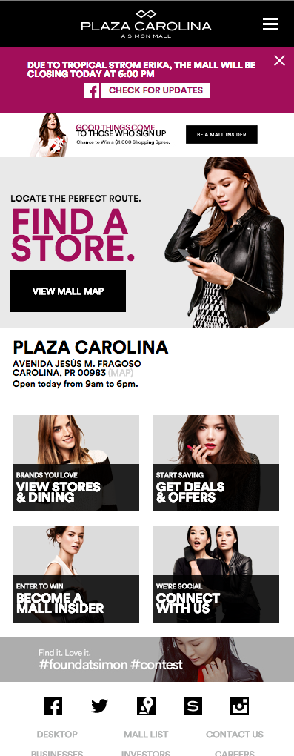

Managing Alerts

Adding a new an Alert
- Go to www.simon.com/login and log into Simon Central
- Click on Manage Consumer Website Content
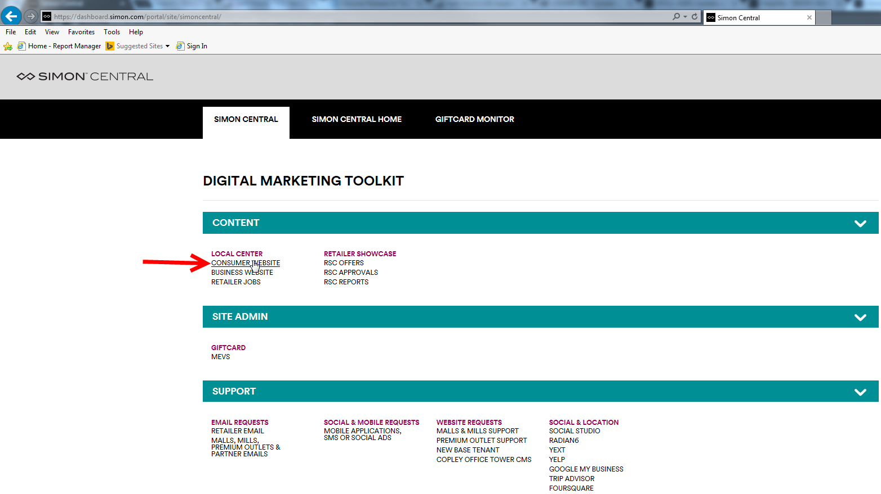
- Go to the mall homepage
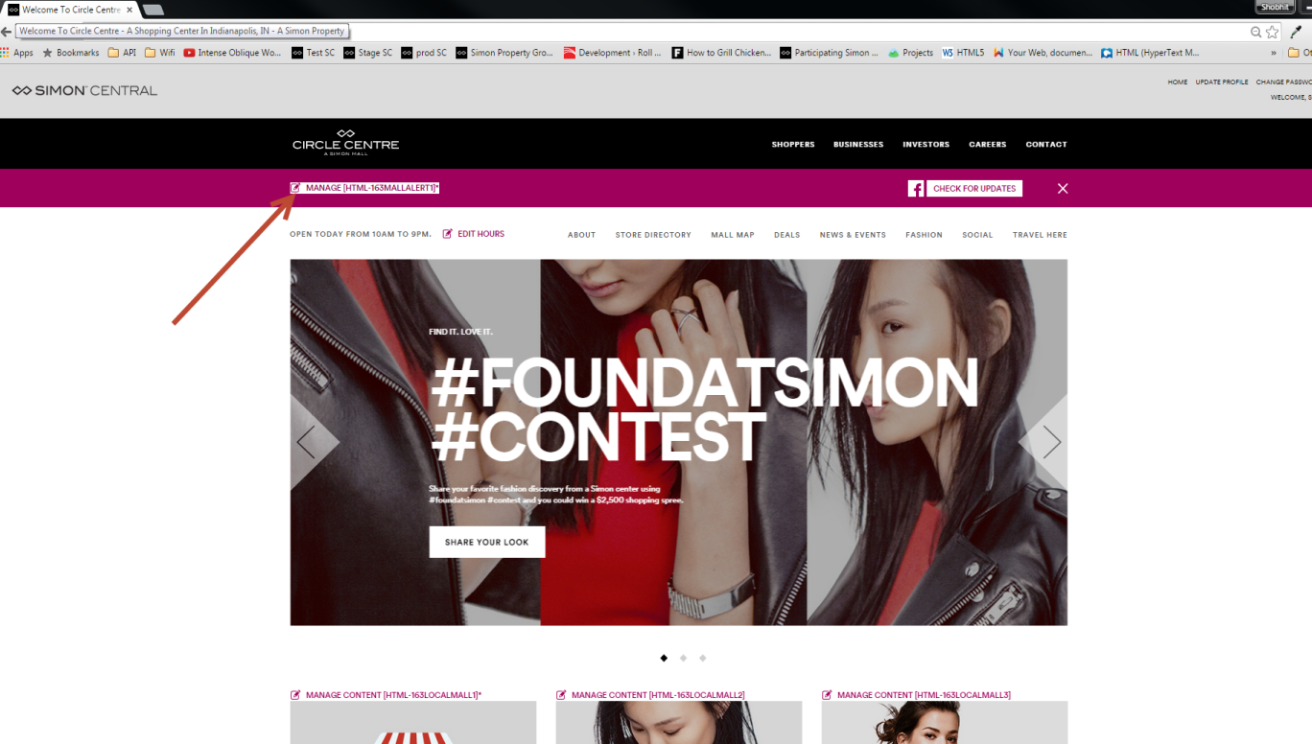
- Once you are on the mall page, click on the manage alert link
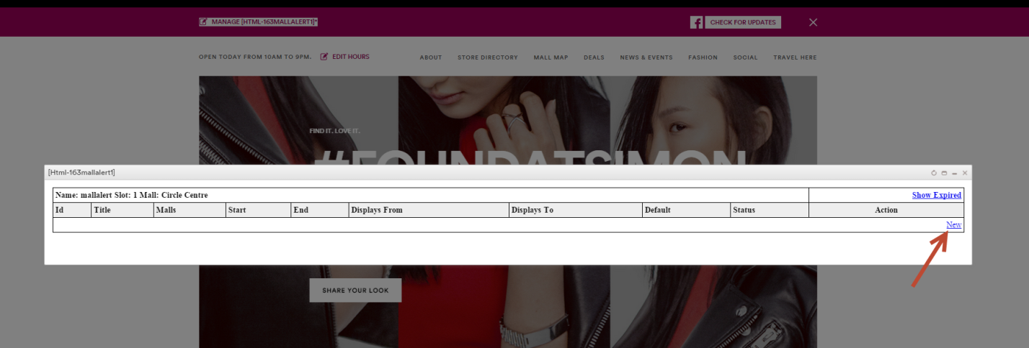
- Click on ‘New’ to create new mall alert.
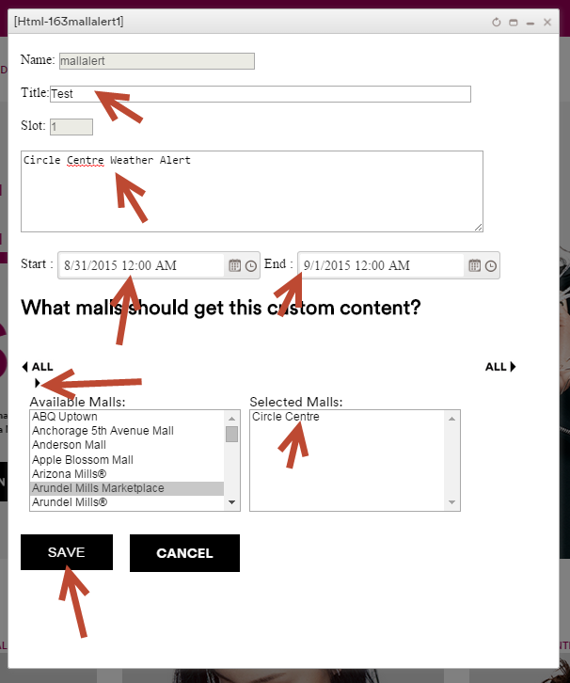
- Enter Title, Description, Start Date, End date and select a mall(s) then click on the arrow pointing to the right and click save

NOTE: Mall list may vary, depending on user’s permission. You will be able to create a new alert for multiple malls but you will have to go to each individual mall to publish it.

- Click Publish, you will see a confirmation pop-up, click OK
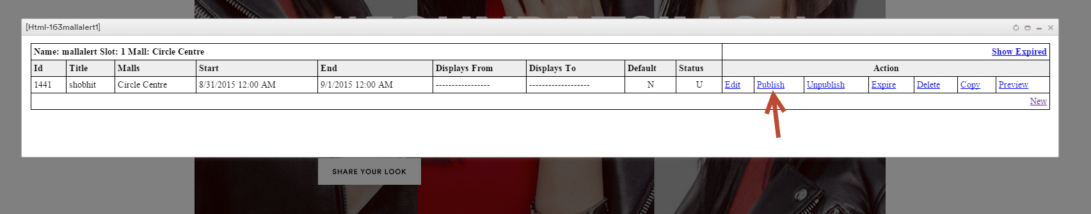
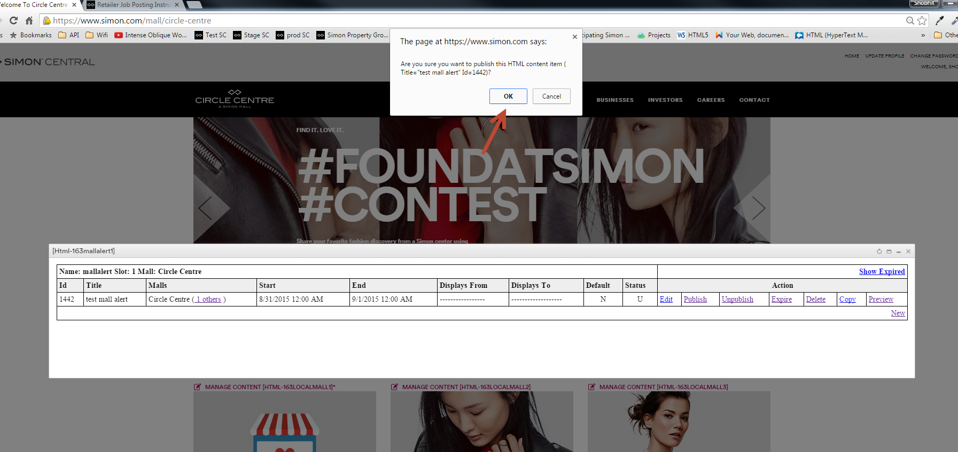

Editing An Existing News Alert
- Click Edit
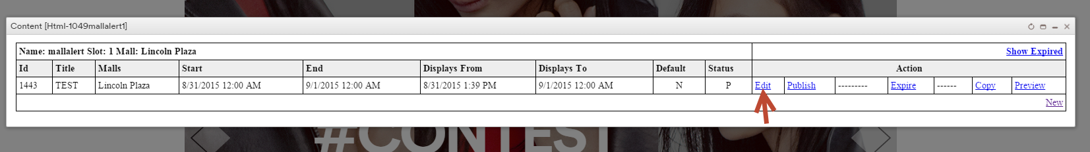
- Mall Alert Admin will appear, make the changes then click on ‘SAVE’ and then ‘OK’.
NOTE: You will see a confirmation pop-up after clicking on ‘SAVE’, letting you know that this your changes will go live as soon as you press OK. You may have to refresh the page in order see the new changes.

Expire/Delete/Copy/Preview A News Alert
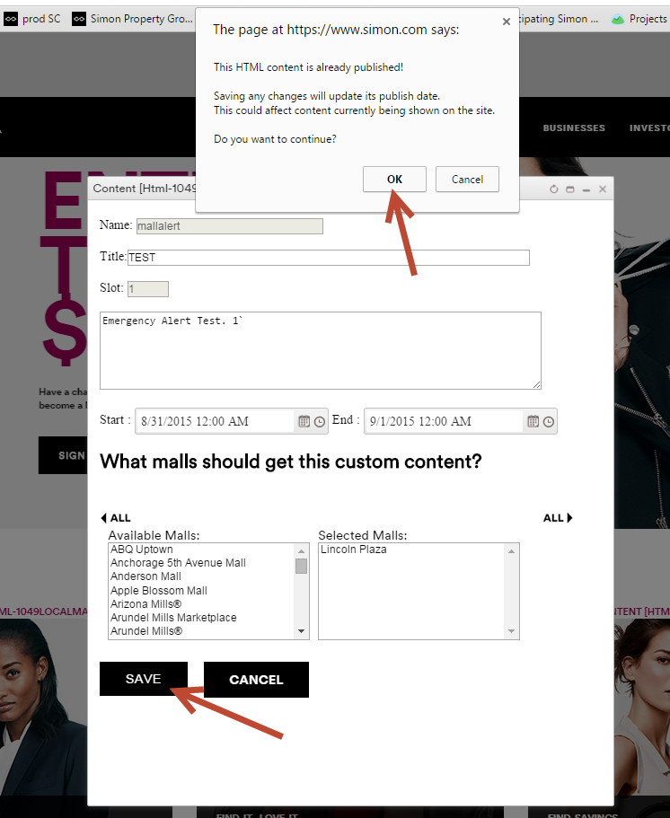
- Click on Expire, you will notice that a confirmation message will appear, click ‘OK’.
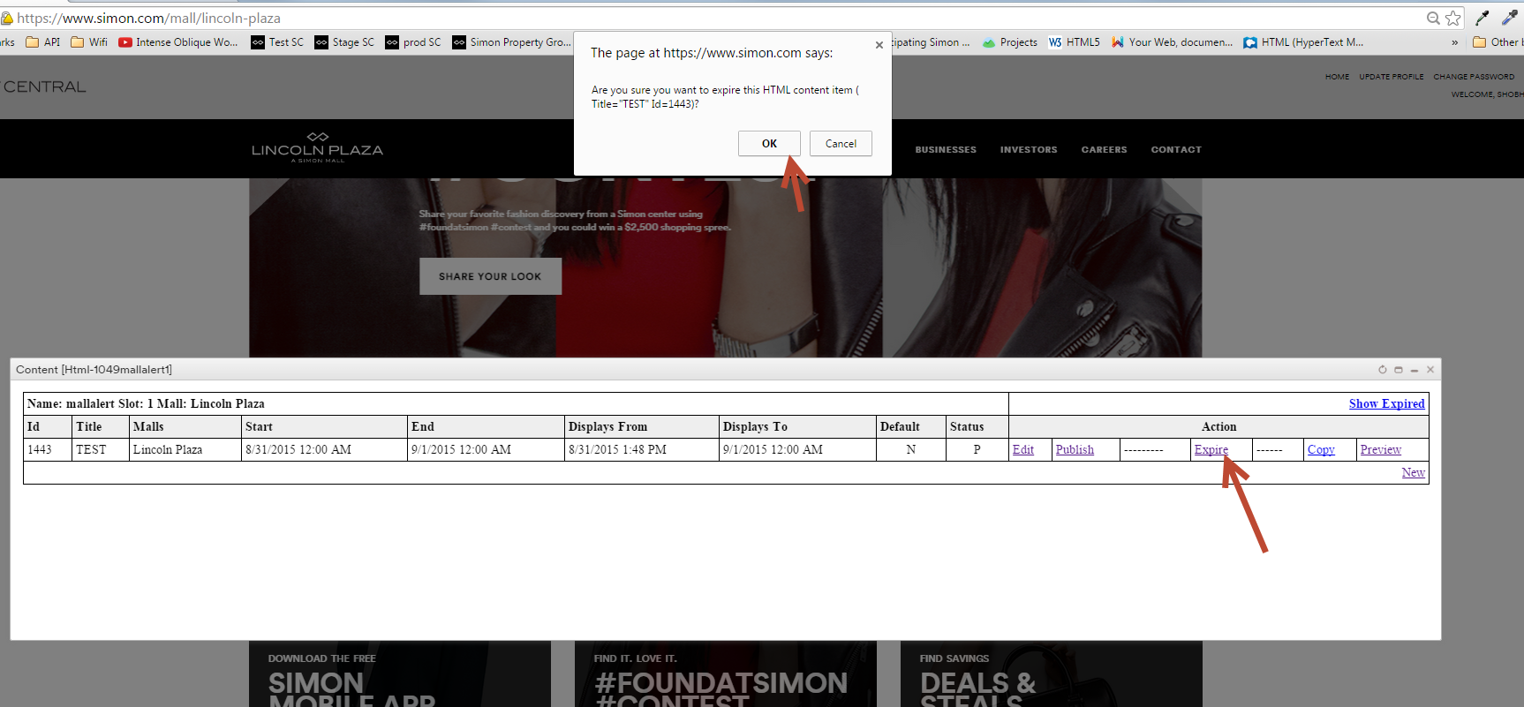
- To see all expired mall alert posts, please click on ‘Show Expired’.
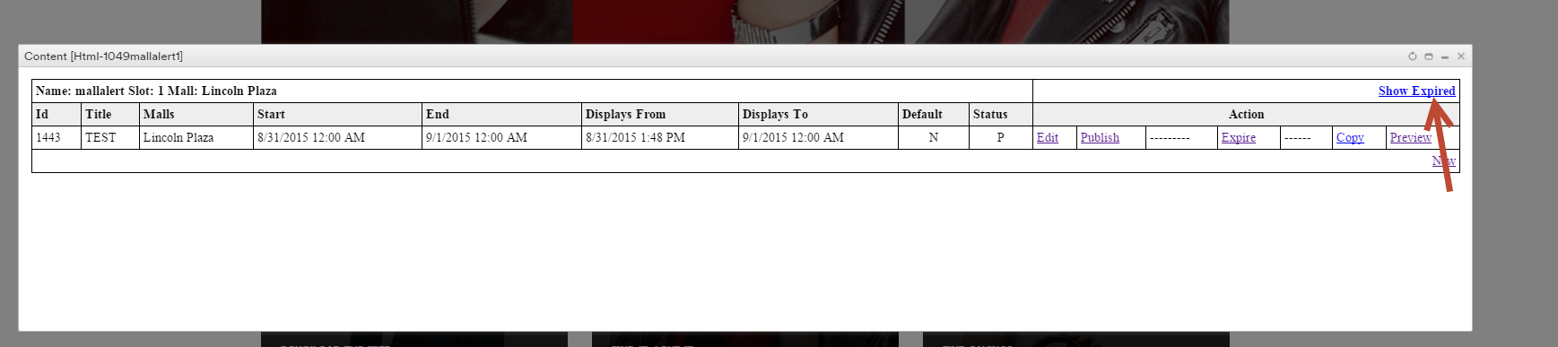
- If you would like to delete a post that was previously published click on ‘Show Expired’ then click on ‘Delete’
NOTE: To delete existing published mall alert you must expire an alert before deleting an alert.
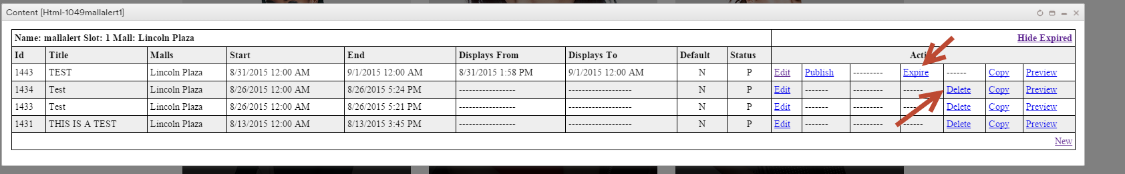
- To Copy a mall alert, click ‘Copy’, then mall alert admin window will appear, make any changes, if there are then click on ‘SAVE’ then click on ‘Publish’

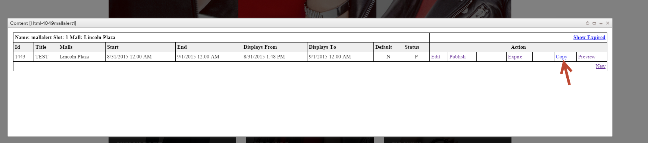
- To preview an alert before publishing it click on ‘Preview’ then scroll up to check alert.
