What Is the Simon+ Rewards program?

Simon+ is a rewards program that lets you get Cash Back, Points, Rewards, and Exclusive Offers when you shop at Simon Malls®, the Mills®, Premium Outlets® that are participating in the Rewards Program (each a “Center”), at Participating Stores (See list of Participating Stores), online at ShopSimon™ or other Merchant Sites, and through the ShopSimon app. As a Member, you can get Cash Back and Points when you shop Participating Stores at a Simon Center, online, or via the app, unlock special deals, discounts, and Members-only Rewards. The more you shop, the more Rewards you can redeem — all in one easy-to-use program.What is a VIP Coupon?

How to request a VIP Coupon or Deal Around Town

- Open your web browser and go to retailersupport.simon.com. Click the tile ‘Add/Edit Exclusive Offers’ or simply go to this direct link.

You may submit a ticket without registering for an account or signing in.

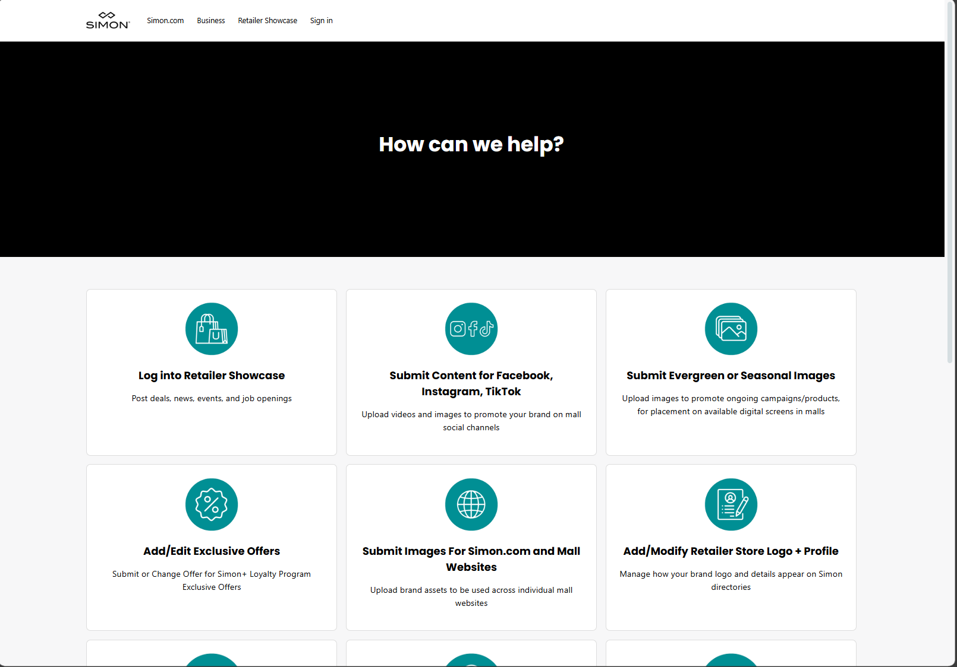

- Fill in the required fields plus any additional fields that may help us better assist you
- Click Submit
  - You will receive a notification on the page and an email will be sent to the address you provided, notifying you that we have received your ticket

How to check up on the status of your ticket and add additional details

Click ‘Sign in’ at the top of retailersupport.simon.com to see your ticket history.


If you've communicated with our support staff through email previously, you're already registered. You probably don't have a password yet, though. For example, if you submitted a ticket as a guest like outlined above, your account gets created automatically. To set a password click ‘Sign In’ at the top right of helpme.simon.com. Then click ‘Get a password’ on the pop-up.

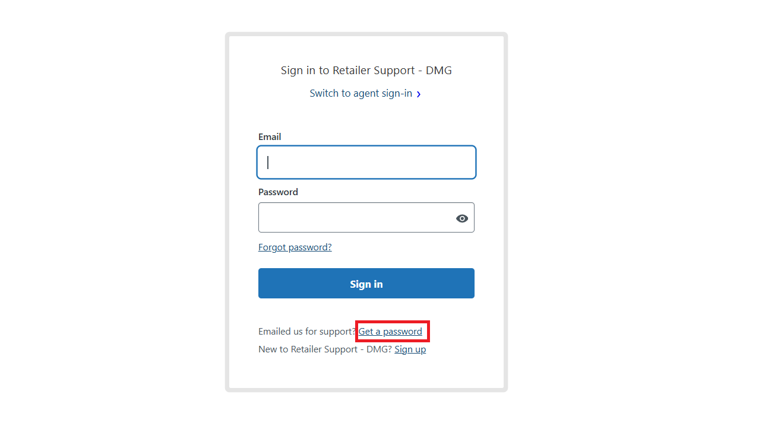

If you would like to provide more details on a ticket without signing in, you can simply reply to system generated emails from your own inbox. You will receive an email anytime there is an update or change in status on your ticket.

