Contents

How to Access Simon Central
Simon.com and Premiumoutlets.com Content Management
Mall Phone Numbers
Mall Regular Hours
Mall Special hours (Holiday/Temporary non-recurring hours)
Mall Alert Banners (ie: weather alerts and mall closings)
Mall Description
Featured stores
Driving Directions
Located on the "About" page, the Directions & Transportation section will help visitors traveling to your property.
Amenities
Travel Content
Store Directory
Business/Leasing Website Management - business.simon.com
Property description
Key Tenants
Editing and Adding Mall Contacts
Adding Retailer Jobs - http://careers.simon.com/retailer-job-openings
Retailer Showcase Management
Posting Guide
Edit a Retailer Showcase post
Manage Pending Posts
Manage Pending Registrations
RSC FAQ
Why can’t I find a retailer in the RSC drop down list?
I received an email about a pending registration or a pending offer, but when I log in to RSC, I can’t find it.
Why can’t I approve this pending registration or offer?
I need a post taken down from our site and I can’t edit it
How do I receive email notifications about pending registrations and offers; or how can I change the recipient?
Where to go when you need help with Digital Marketing platforms?

How to Access Simon Central
Simon Central Login URL: https://www.simon.com/simoncentral
You can log in with Simon Central with your Simon Network account via Single-Sign-On. Simply enter your Simon email address at the login URL and click “Sign in with Microsoft”.
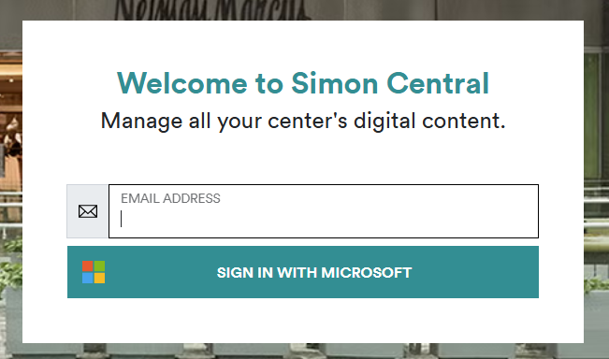
It will redirect you to page like this where you will sign on with your @simon.com email address and Simon network credentials. You may also have to use the 2 factor authentication to complete the login.
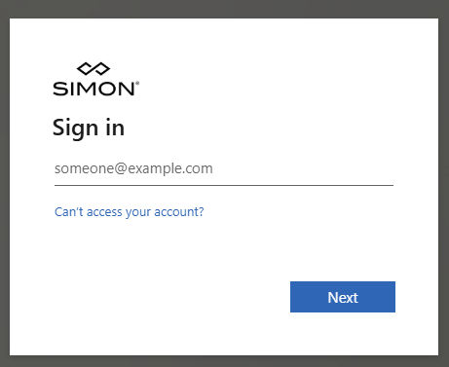

After logging into the portal you will see the Simon Central hub with all the links you’ll need for managing your website data.
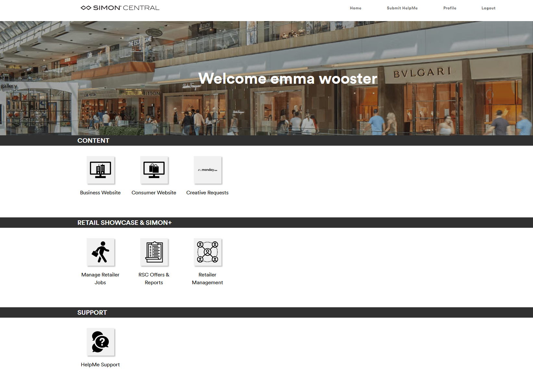

Forgot Password?
If you forgot your password please call the Simon Information Services Help Desk.

Simon.com and Premiumoutlets.com Content Management
Log into Simon Central. Click ‘Manage Consumer Website Content’. You will be automatically taken to your mall’s homepage, or if you manage multiple websites you will be taken to www.simon.com/mall. Select your mall.

Mall Phone Numbers
Click the ‘ABOUT’ link. Click ‘EDIT PHONE NUMBERS’ to open the editor. Here you can add Mall Management, Shopping Line, and Security Hotline. Click ‘PREVIEW’ to save a draft of your changes and close the window. To publish the changes to the website, click the ‘PUBLISH’ button on the plum banner that appears. Your changes will not display until this happens. If you click discard your changes will be thrown out.
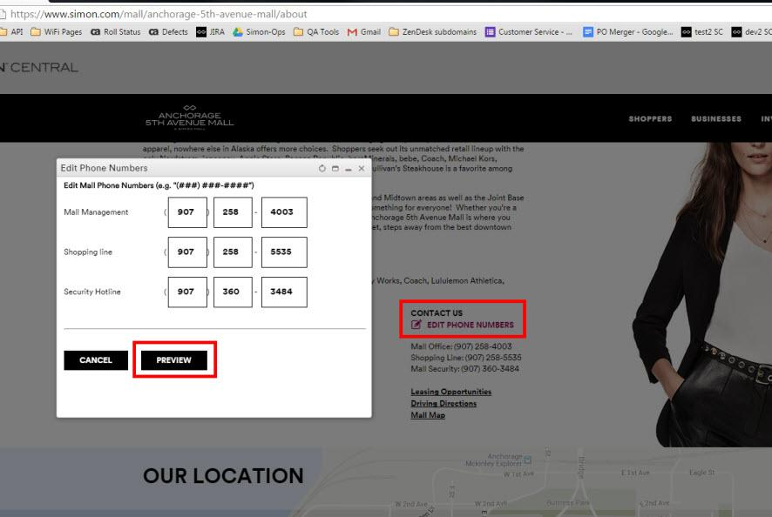
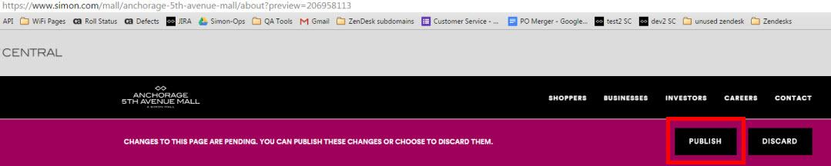

Mall Regular Hours
Important note about hours: The stores in your directory will automatically inherit the mall’s hours unless you specify different hours for the store. This applies to both regular mall hours or holiday hours. To set store hours skip ahead to the tenant hours guide.
- Step 1: Log into Simon Central
- Step 2: Click ‘Manage Consumer Website Content’
- Step 3: Navigate to your mall’s homepage
- Step 4: Click ‘EDIT HOURS’
- Step 5: Ensure the Regular Hours radio button is selected
- Step 6: To add new hours, enter in a start day, end day, open time, and close time. If the mall is closed, simply check the box.
- Step 7: Click ‘ADD NEW HOURS’
- Step 8: Click ‘PREVIEW’
- Step 9: Click ‘PUBLISH’
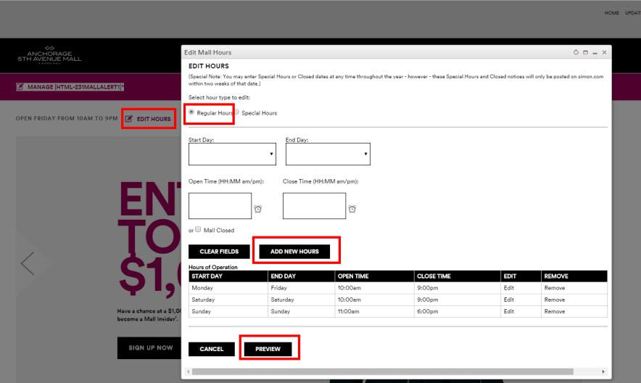

Mall Special hours (Holiday/Temporary non-recurring hours)
Important note about hours: The stores in your directory will automatically inherit the mall’s hours unless you specify different hours for the store. This applies to both regular mall hours or holiday hours. To set store hours skip ahead to the tenant hours guide.
Video Tutorial: http://screencast.com/t/ovaWXp2wAYtL
- Step 1: Log into Simon Central
- Step 2: Click ‘Manage Consumer Website Content’
- Step 3: Navigate to your mall’s homepage
- Step 4: Click ‘EDIT HOURS’
- Step 5: Select the ‘Special Hours’ radio button
- Step 6: Select a Description, Start Date, End Date & Open Time, Close time or check the Mall Closed box
- Step 7: Click ‘ADD NEW HOURS’
- Step 8: Click ‘PREVIEW’ to close the editor and preview your changes
  - NOTE: Depending on what dates you entered, you may not be able to preview the display. The website only shows up to 2 weeks into the future of special hours. If you don’t see your changes, don’t worry. Simply continue to the next step and publish
- Step 9: Click ‘PUBLISH’ in the banner at the top of the page
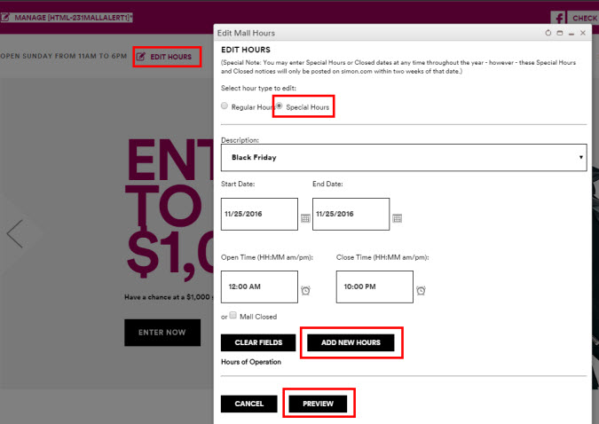

Mall Alert Banners (ie: weather alerts and mall closings)
Located on all mall desktop and mobile pages, the Mall Alert notifies shoppers of urgent news such as a mall closing due to inclement weather. This alert can be hidden from users by clicking on the ‘X’ on the banner and it will not show again unless they clear browser cookies.
To update this information follow these steps:
- Step 1: Log into Simon Central
- Step 2: Click ‘Manage Consumer Website Content’
- Step 3: Navigate to your mall’s homepage
- Step 4: Click ‘MANAGE [HTML-##MALLALERT1] in the pink banner at the top of the page
- Step 5: Click ‘New’ to add a new alert or click on ‘Edit’ in the list of current alerts; or click ‘Show Expired’ to find a past alert
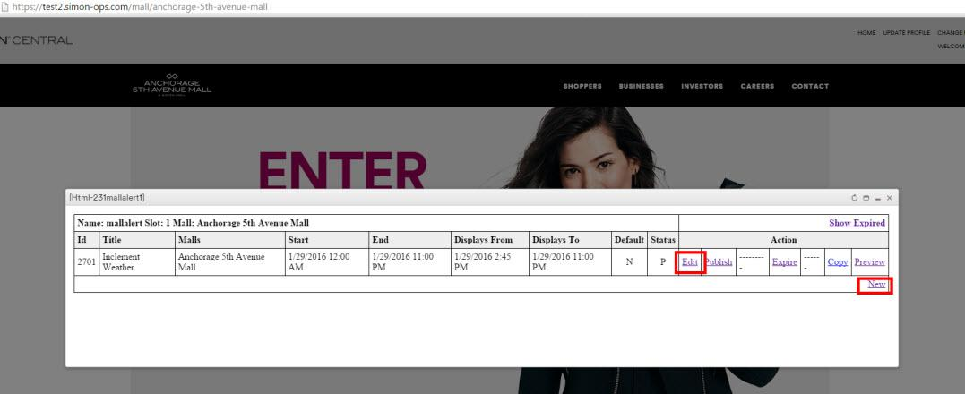
- Step 6: Enter Title, Description, Start Date & Time, End date & Time, and select a mall(s)
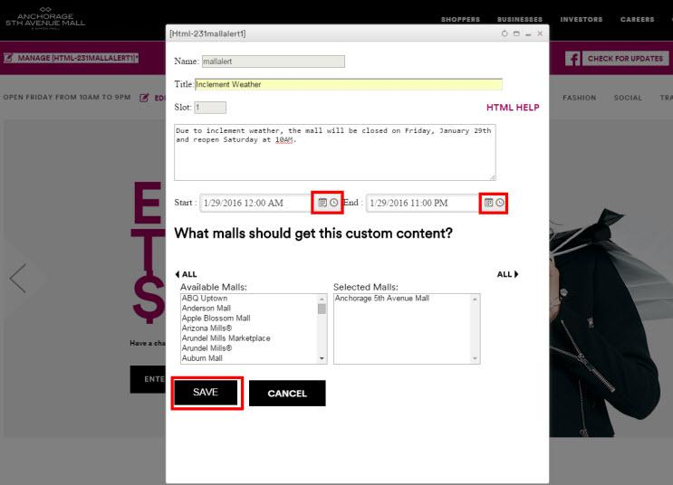
- Step 7a: Click Save
- Step 7b: If you have other active alerts that overlap your specified dates on the new alert you will see this page. To save it anyways click ‘ACCEPT AND SAVE’ or you can go back to the editor to start over.
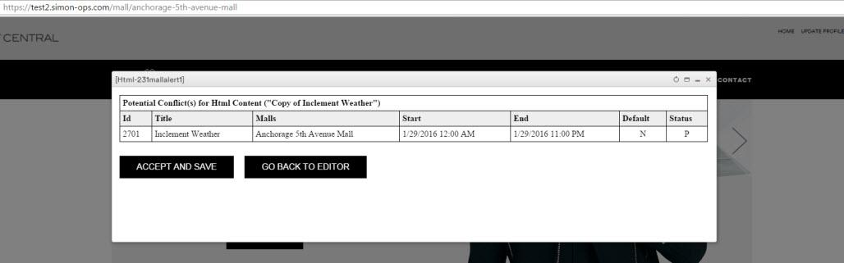
- Step 8: Click Publish next to the mall alert that you want to go live.
NOTE: Published status will show as ‘P’. Draft status is ‘U’. If you have multiple published alerts that overlap in time, the one that will show up will be the most recently published. When one alert expires, the next alert will automatically appear.
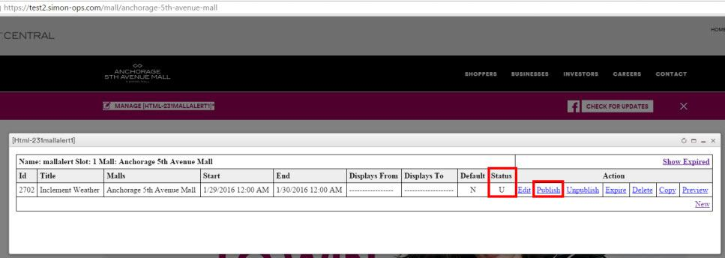

Mall Description
Click the ‘ABOUT’ link. Click ‘EDIT DESCRIPTION’ to open the editor. Enter a descriptive summary of your mall, its location, key retailers and restaurants. It’s up to you. If you copy and paste from Microsoft Word it should strip all of the formatting. You can use the built in tools to format your copy for bolding, italicizing, unordered lists, ordered lists, and hyperlinks. Please avoid excessive formatting or extremely lengthy descriptions. Keep it simple!

Click ‘PREVIEW’ to save a draft of your changes and close the window. To publish the changes to the website, click the ‘PUBLISH’ button on the plum banner that appears.
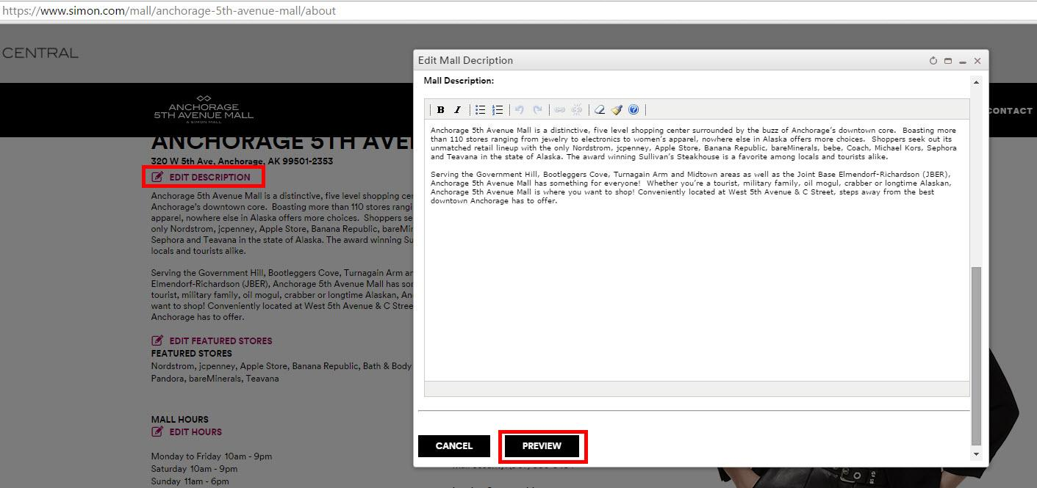

Featured stores
Located on the "About" page, the Featured Stores section highlights the high profile tenants.
To update this information follow these steps:
- Step 1: Log into Simon Central
- Step 2: Click Manage Consumer Website Content
- Step 3: Navigate to your property's "About" page
- Step 4: Scroll down to the new "Featured Stores" section under your mall description and click the ‘EDIT FEATURED STORES’ link
- Step 5: Search for a tenant in the search box and click ‘SEARCH’. If there are no results please ensure that you spelled the tenant correctly AND that the tenant is in your website’s store directory
- Step 6: Click ‘Add’ for the matching tenant under the ‘AVAILABLE STORES’ section
- Step 7: To change the order that the stores appear in the list you can drag and drop the rows
- Step 8: Click ‘PREVIEW’
- Step 9: Click ‘PUBLISH’
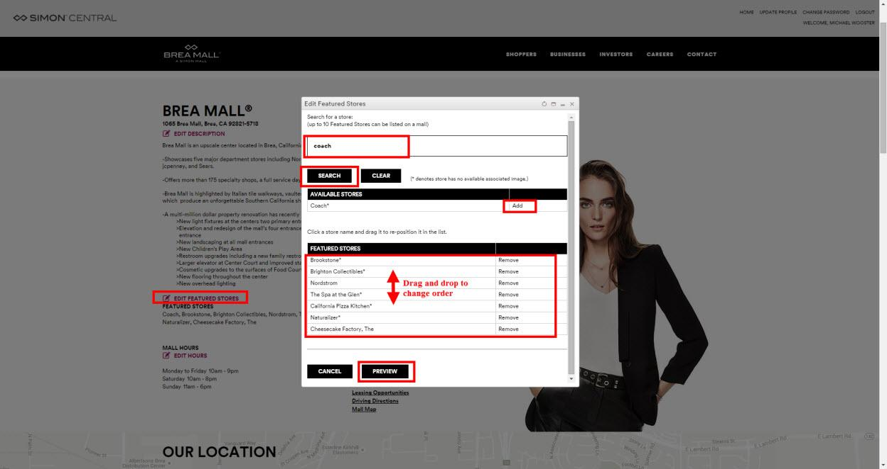

Driving Directions

Located on the "About" page, the Directions & Transportation section will help visitors traveling to your property.
To update this information follow these steps:
- Step 1: Log into Simon Central
- Step 2: Click ‘Manage Consumer Website Content’
- Step 3: Navigate to your property's "About" page
- Step 4: Scroll down to the new "Directions & Transportation" section and click the "Add New" link
- Step 5: Choose the "Driving Direction Type" from the drop down box, and enter the "Driving Direction Description"
- Step 6: Click the "Preview" button to review your changes, then click the "Publish" button (at the top of the page)
Providing multiple methods of transportation and directions will help shoppers get to your property, so please include as many details as possible in the Description. Note that if one of the methods of transportation comes close-to but not directly-to the property, please do use that transportation method and simply include the pertinent information.
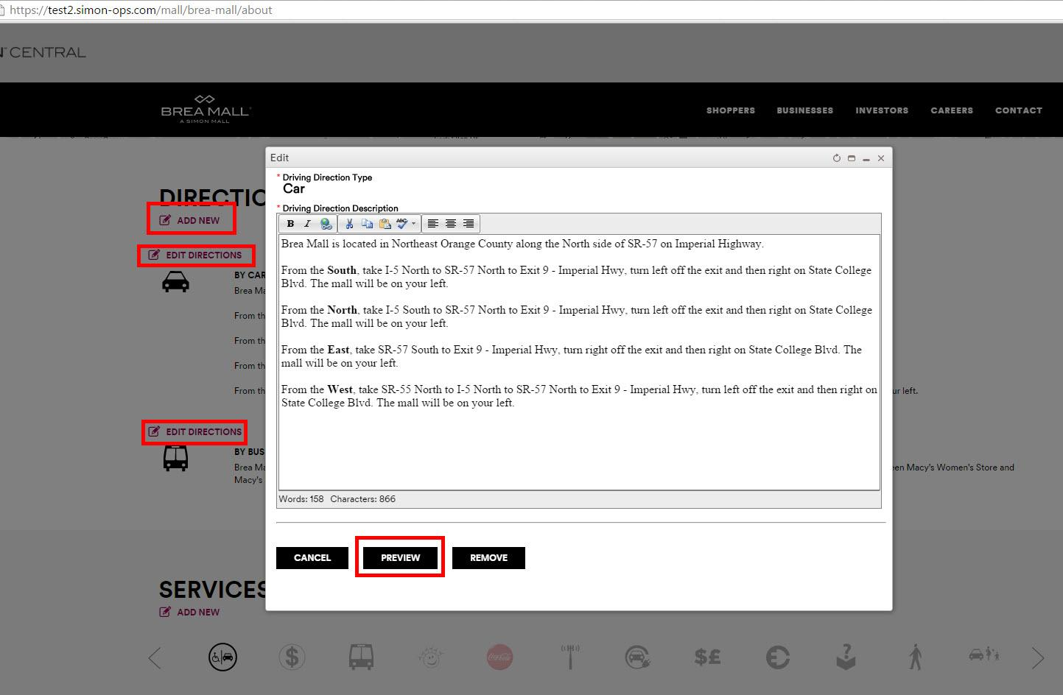

Amenities
Video tutorial: http://screencast.com/t/Qm2wT2yVL0L1
To update this information follow these steps:
- Step 1: Log into Simon Central
- Step 2: Click ‘Manage Consumer Website Content’
- Step 3: Navigate to your property's "About" page
- Step 4: Scroll down to the ‘SERVICES & AMENITIES’ section, Click ‘ADD NEW’
- Step 5: Select the amenity from the drop down list
- Step 6: Enter in a description for the amenity
- Step 7: Click ‘PREVIEW’ to close the editor and preview the amenity
- Step 8: Click ‘PUBLISH’ in the banner at the top

Travel Content
Travel content is managed by the Digital Marketing team. To request an update to this please submit a Help Ticket here: helpme.simon.com

Example pages:
http://www.premiumoutlets.com/outlet/las-vegas-north/travel-here
http://www.simon.com/travel/las-vegas

Store Directory
Video Tutorial: http://screencast.com/t/xVNJJtbgE
Step 1: Log into Simon Central
Step 2: Click Manage Consumer Website Content
Step 3: Navigate to your mall’s website
Step 4: Click ‘ADD NEW TENANT’. This will take you to a blank store page.
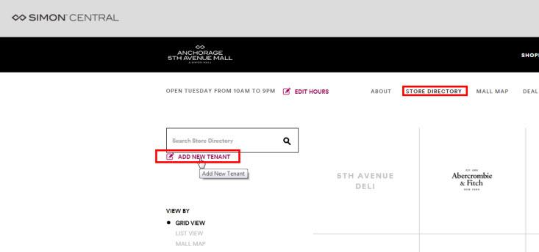
Step 5: Click ‘EDIT TENANT’ to open the editor.
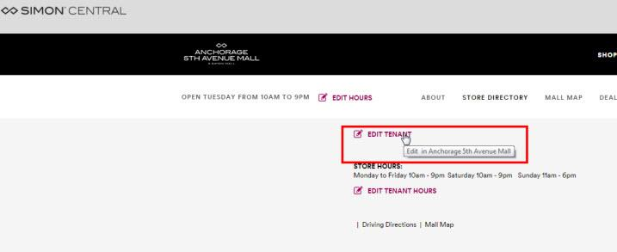
Step 6: Begin typing in the field labeled ‘TYPE A NEW BASE TENANT NAME’ and select the tenant from the drop down
TIP: If you don’t see what you are looking for, first confirm the spelling is correct. Try typing a different variation of the name that is less specific. If you still find no results it means we have no base tenant profile created. You will need to request one by going to helpme.simon.com
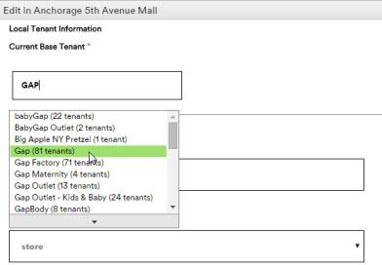

Step 7: Fill in as many fields as applicable. Continue reading for a description of the fields.

Store Display Name
Automatically defaults to the base tenant’s name. If you want to customize how the store is branded in your mall you can change the display name here. For example, if you had a base tenant called ‘Disney Store’ but you wanted to show it as ‘The Disney Store’ you would change the display name.

Tip: If you change the display name it will affect the URL address of the store page
www.simon.com/mall/[mall-name]/stores/[store-display-name]
www.premiumoutlets.com/outlet/[outlet-name]/stores/[store-display-name]

Tip: This will NOT affect the name that shows up within Retailer Showcase or www.simon.com/brands. These applications use the Base Tenant Name exclusively. The display name affects only your website.

Tenant Location Type* (drop down)
Retail Tenant
Kiosk
Anchor

Opening Date
Type in the date the tenant opens. Stores with a future opening date will display as ‘COMING SOON’ on the site
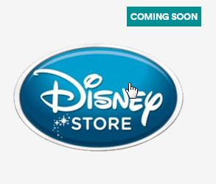

Stores that just opening will display ‘NEW’ for up to 2 weeks after the opening date
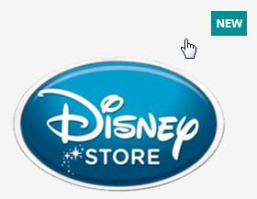

Description
If your tenant provided you a description of the store, here is the place to enter it. We will automatically show the description saved in the base tenant profile if you enter in nothing here. I recommend leaving this blank so you can see the default description first. If changes need made you can go back to edit the tenant.

Tip: Want to update the store description across multiple malls? We will need to change the base tenant name. Submit a request here: helpme.simon.com

Hours
To edit a tenant hours click ‘EDIT TENANT HOURS’ from the store’s page. The editor works just like the mall’s hours editor.

Important note on store hours: Remember that stores will automatically inherit both the mall’s regular hours and special hours. You only need to enter in a store’s hours if the store operates at hours different from the mall. For example, you might have a restaurant or anchor that is open later than the mall. In this case you would want to add store hours.

So what if the mall has special hours due to a holiday or an unexpected closing? Do I still have to add special hours for the store?

If the store is not following these mall’s special hours, YES. Even if you have added individual regular hours for the store, it will inherit the mall’s special hours because special hours always take precedence. If you don’t want the store to display mall special hours you will also have to add special hours for the store on the same dates.

Phone Number
Website
Best Entrance / Closest Parking
Location description
Tenant Categories
All categories available are pre-checked. You can uncheck any that you want, but you will need at least 1 category enabled. Grayed-out categories means they are not enabled in the base tenant profile. To update the available categories, submit a request here: helpme.simon.com

Business/Leasing Website Management - business.simon.com
- Step 1: Log into Simon Central
- Step 2: Click ‘Manage Business & Leasing Website Content’
- Step 3: Navigate to your property's leasing page

Property description
To edit the B2B description, click on ‘EDIT PROPERTY HIGHLIGHTS’. This should be targeted towards prospective tenants as opposed to the shopper description on your B2C website.

Key Tenants
To change the key tenants, request a change here: helpme.simon.com

Editing and Adding Mall Contacts
To see a quick summary of all contacts at your mall click on ‘EDIT MALL CONTACTS’
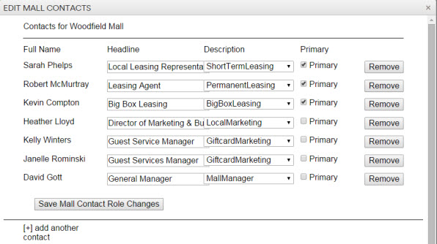
To edit the roles of a contact that has responsibilities at multiple properties scroll to their name on the page and click ‘EDIT’
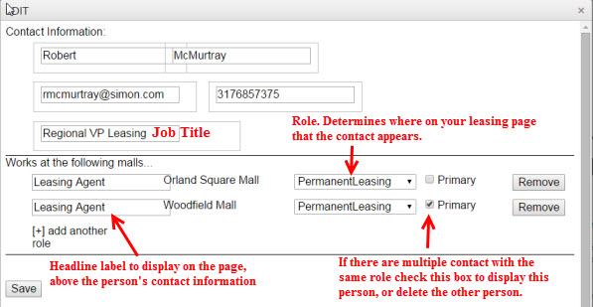
To remove the user from your mall, or other malls click the ‘Remove’ button next to the corresponding roles. If you delete every role the contact is deleted altogether and will not appear anywhere on the site.
To add a new contact you can either click ‘ADD CONTACT’ or go into the ‘EDIT MALL CONTACTS’ editor and click ‘[+] add another contact’. The steps will be the same either way.
- Fill in the contact information:
  - First NAme
  - Last NAme
  - Email Address
  - Phone Number
  - Job Title
- IMPORTANT: click [+] add another role to attach a mall to the contact.
  - Add a headline (the label to display above the contact’s name on the page)
  - Select the mall name from the drop down
  - Select a type from the drop down. This determines where on the page the contact will show
  - If there are multiple contacts with the same ‘Type’ the one checked Primary will show.
- Click ‘Save’

Adding Retailer Jobs - http://careers.simon.com/retailer-job-openings
This guide will help you with job postings for your tenants.
- Step 1: Log into Simon Central
- Step 2: Click Manage Retailer Job Postings
- Step 3: To add a job click the black button labeled ‘ADD A JOB’. To edit or delete a job click on the corresponding teal-colored buttons next to the job in the table
- Step 4: Fill in the Job title, Property Name, Retailer Name, Category, Job Type, Description, Post Date, and Pull Date
  - NOTE: If the retailer does not show in the drop down list, you have to add the store to your website directory
  - NOTE: If you are copying and pasting from Microsoft Word, please make sure to clean up the formatting as best you can. If there is too much formatting you don’t want from the Word doc, a useful trick is to first paste the text into a simple Notepad file to strip formatting.
- Step 5: Click ‘PREVIEW’
- Step 6: Click ‘PUBLISH’
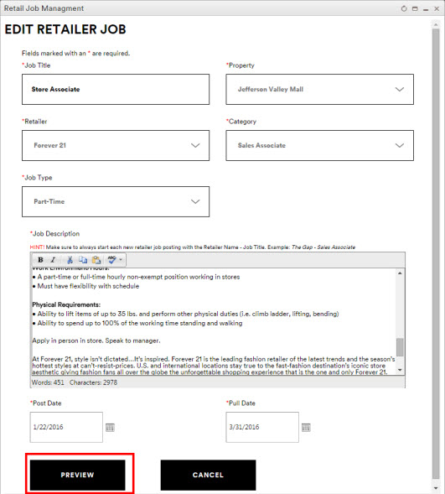
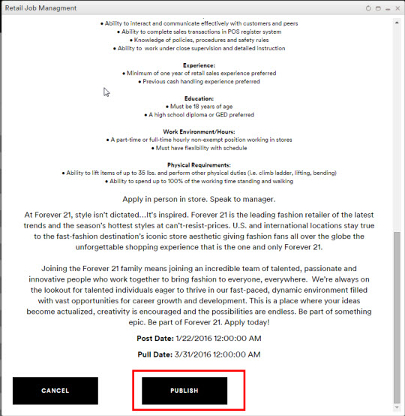

Retailer Showcase Management

Posting Guide
For a full guide please visit the page below and download the PDF. This guide will work for both retailers and Simon Employees, so feel free to share it with your tenants.
Guide: https://helpme.simon.com/hc/en-us/articles/360024589531-Guide-to-Creating-Deals-News-Events-Within-Simon-s-Retailer-Showcase

Edit a Retailer Showcase post
By default, the table at the bottom of the page will show pending content, but you can search or filter for other content.
Search for a post by:
- Title -OR-
- Filter by..
  - Type
  - Status
  - Mall Name
  - Retailer (begin typing and then select from the result list)

Manage Pending Posts
- Step 1: Log into Simon Central
- Step 2: Click on ‘Retailer Showcase Offer Management’
- Step 3: By default, the table at the bottom of the page will show pending content. Select the posts you want to review by clicking on the hyperlinked title
Reasons why you might deny a post. (Including but not limited to)
- No imagery included
- Poorly sized or pixelated image
- Offensive content
- Spelling errors
- Content was posted as the wrong type (remember- sales events are not ‘Events’ or ‘News’ and should be posted as ‘Offers’)
- Post date or valid to/from date look incorrect
- Content was already posted by someone else

Manage Pending Registrations
- Step 1: Log into Simon Central
- Step 2: Click on ‘Retailer Showcase Registration Management’
  - NOTE: The page will automatically show pending registrations for your mall. You will only be able to approve registrations for malls that you manage. If a registration is for your mall but ALSO at malls you don’t manage, it will have to be approved by the Digital Marketing team. We go through multi-mall registrations and approve or deny them on a daily basis.
  - The easiest way to identify a registration you can approve or deny is by looking at the ‘Mall’ column which will show you the mall name if it is only for 1 mall or it will show a count of how many malls the registration is for
- Step 3: Click ‘REVIEW’ next to the registration you want to manage
- Step 4: Click ‘APPROVE’ or ‘DENY’ as appropriate
  - If you do not see these buttons, refer to the NOTE above.
  - One reason you might want to deny a registration is because the user selected the incorrect retailer(s) or mall. Use your best judgement.
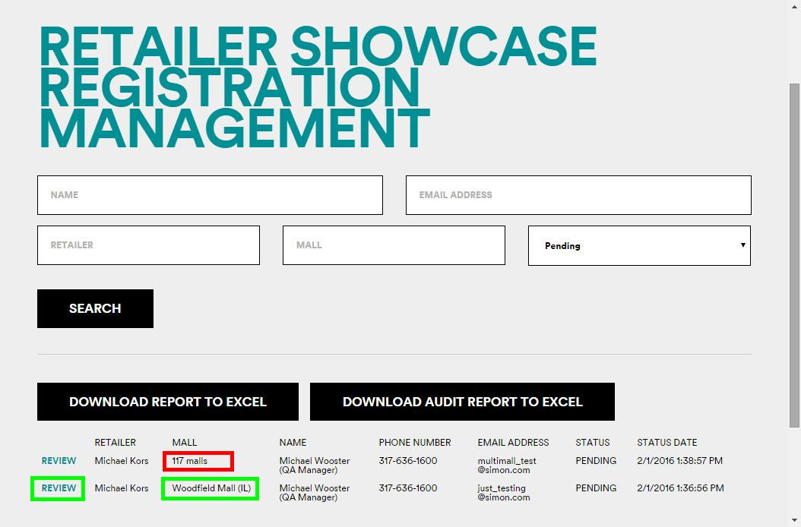
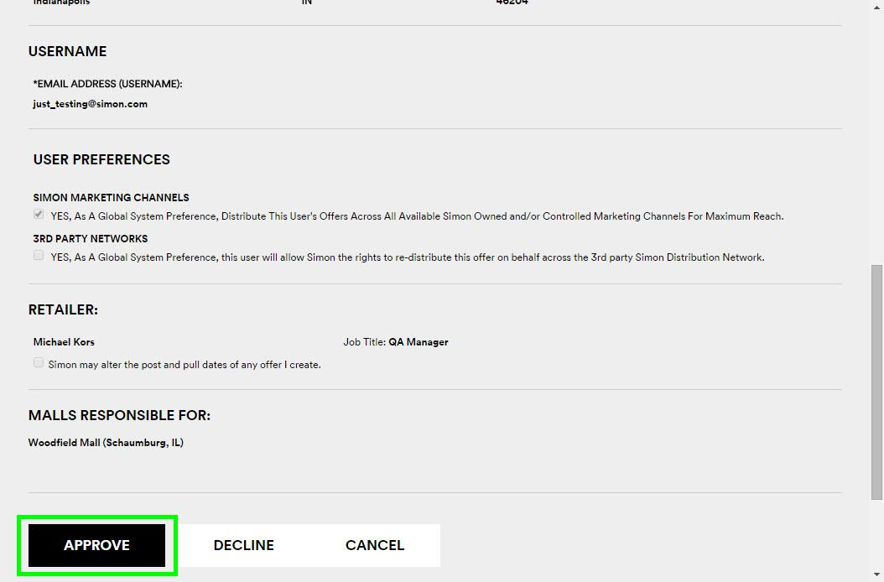

RSC FAQ

Why can’t I find a retailer in the RSC drop down list?
If the store is not in your website directory, it will not show in Retailer Showcase. If you believe the store is in your website directory, try searching for the store under a different branding. Remember, Retailer Showcase uses the base tenant name (the same branding that applies at EVERY store). If you customized the display name of the store for your website it will not use that name here. You can look up which base tenant the store is associated to by opening up the tenant editor window.

I received an email about a pending registration or a pending offer, but when I log in to RSC, I can’t find it.
The registration or post has probably already been approved or denied. The Digital Marketing team goes through the list at least once a day Monday-Friday.

Why can’t I approve this pending registration or offer?
You can only approve content for the malls you manage. Registrations and posts that span multiple malls will be reviewed by the Digital Marketing team.

I need a post taken down from our site and I can’t edit it
The person who originally created the content should be able to expire the post. If there is a problem or it is an emergency you can submit a ticket to Digital Marketing here: helpme.simon.com

How do I receive email notifications about pending registrations and offers; or how can I change the recipient?
Submit a ticket to Digital Marketing: helpme.simon.com

Where to go when you need help with Digital Marketing platforms?
Go to helpme.simon.com and fill out a ticket. We can assist you with anything relating to the desktop or mobile website or our mobile apps on iOS and Android.

